**1.Introduction:**

**Indian agriculture began by 9000 BCE as a result of early cultivation of plants, and domestication of crops and animals.**

**1.1.Overview:**

**According to The World Bank, India is a global agricultural powerhouse. It is the largest producer of rice, wheat, cotton, sugarcane, etc.**

**1.2.Purpose:**

**India is the second-populous country in the world. And to feed such a huge population, there is always a constant need for a supply of food.**

**2.Problem Statement & Design thinking:**

**The present challenges the plague Indian agriculture are limited knowledge and insufficient infrastructure, especially in the rural areas. A company could use design thinking to create new harvester that is more versatile and adaptable to different crops.**

**2.1.Empathy map:**

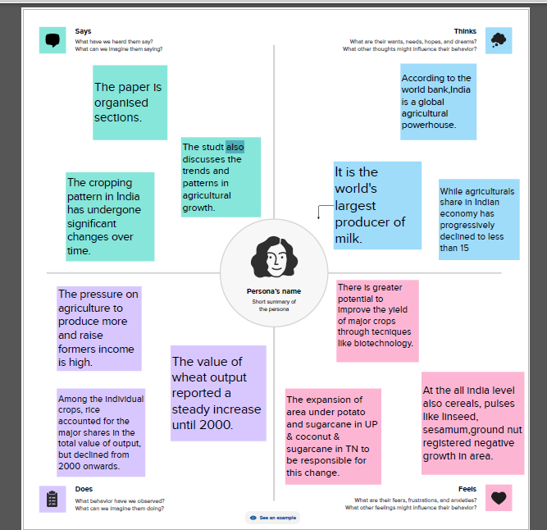

**2.2.Ideation and Brainstorming Map**:

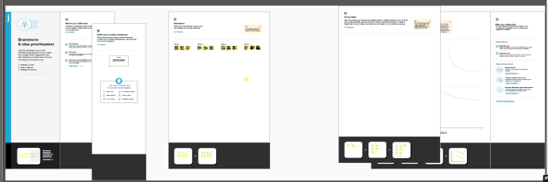

3.Result:

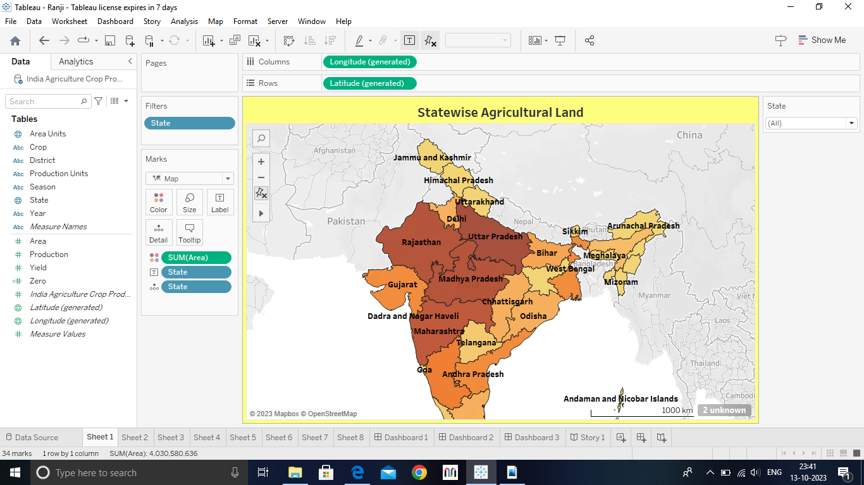 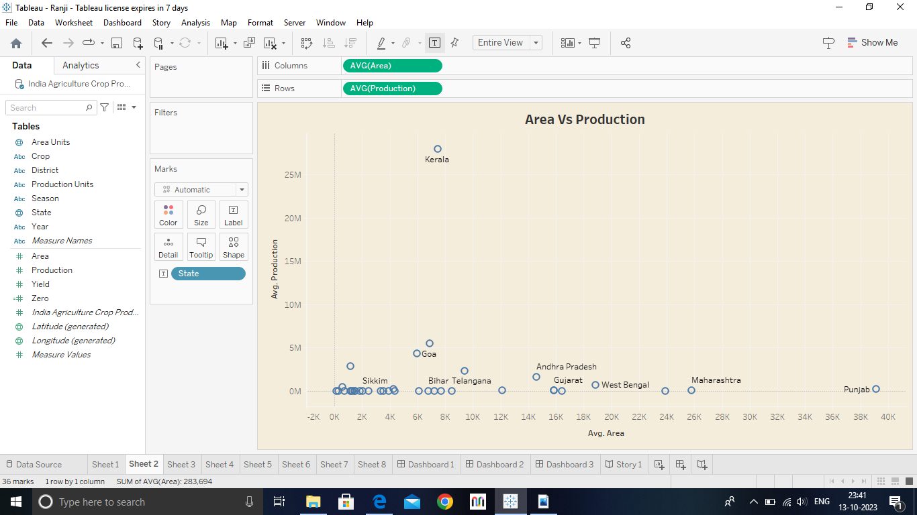 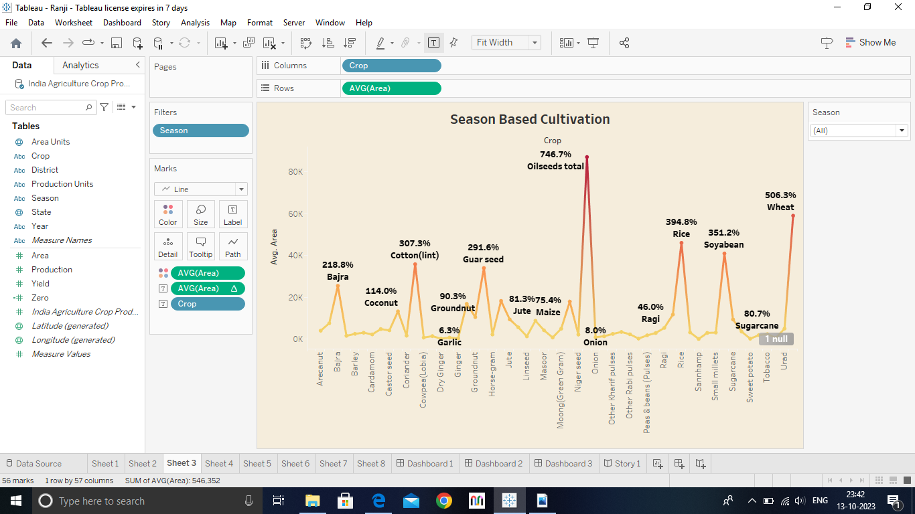 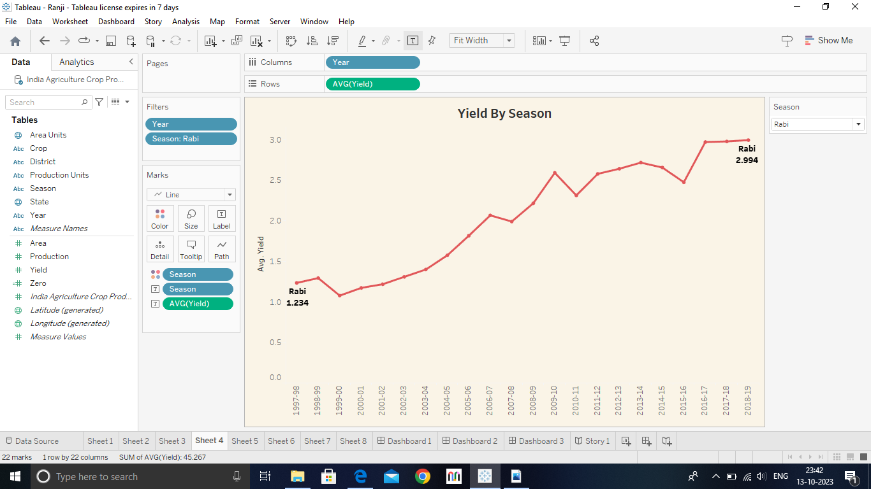 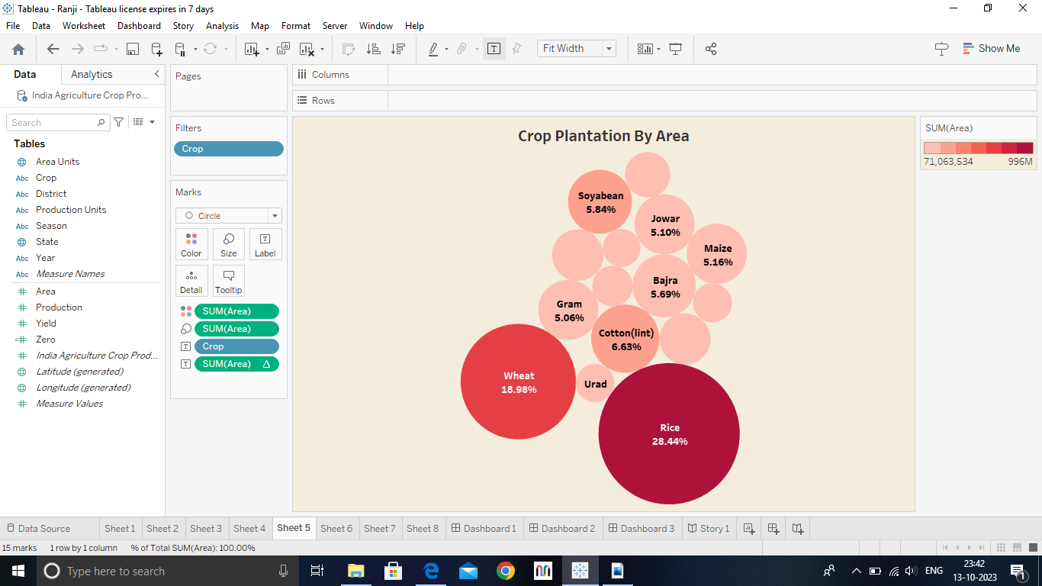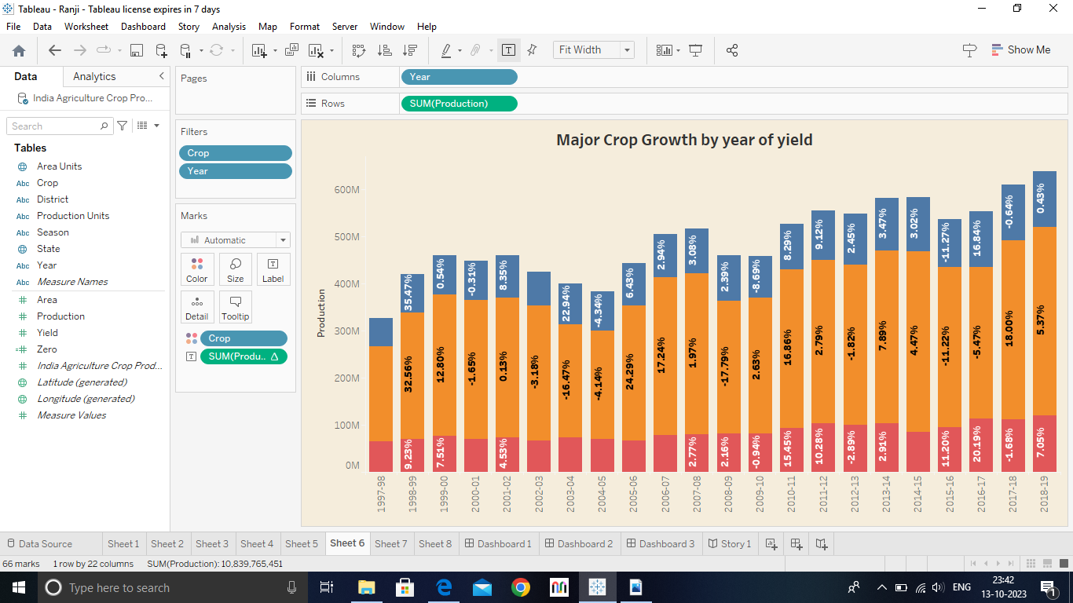

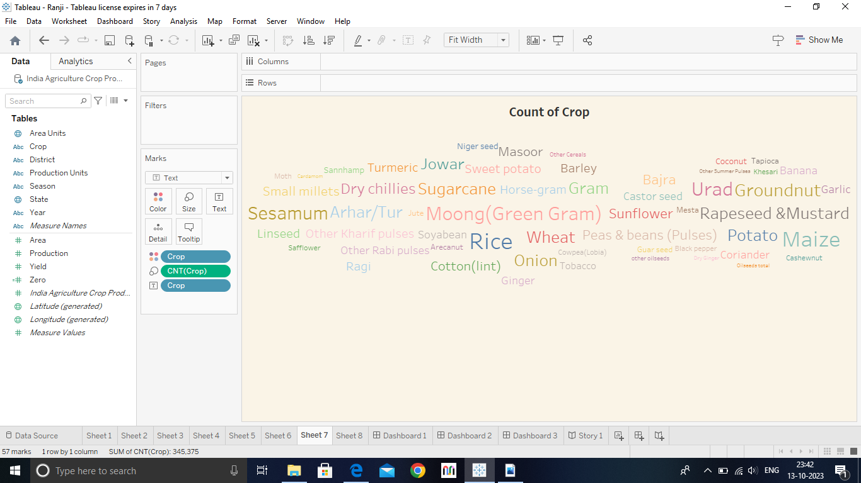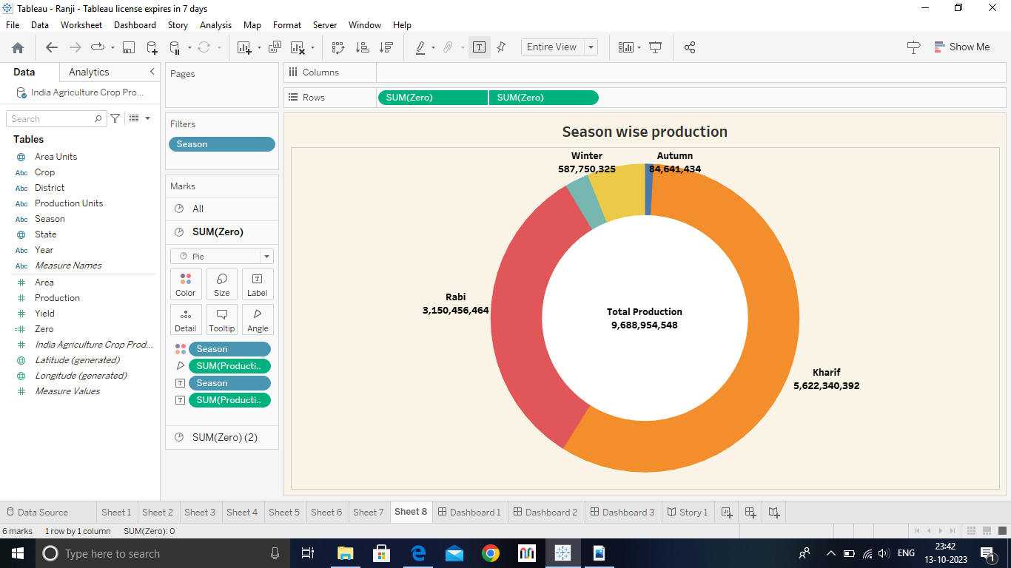

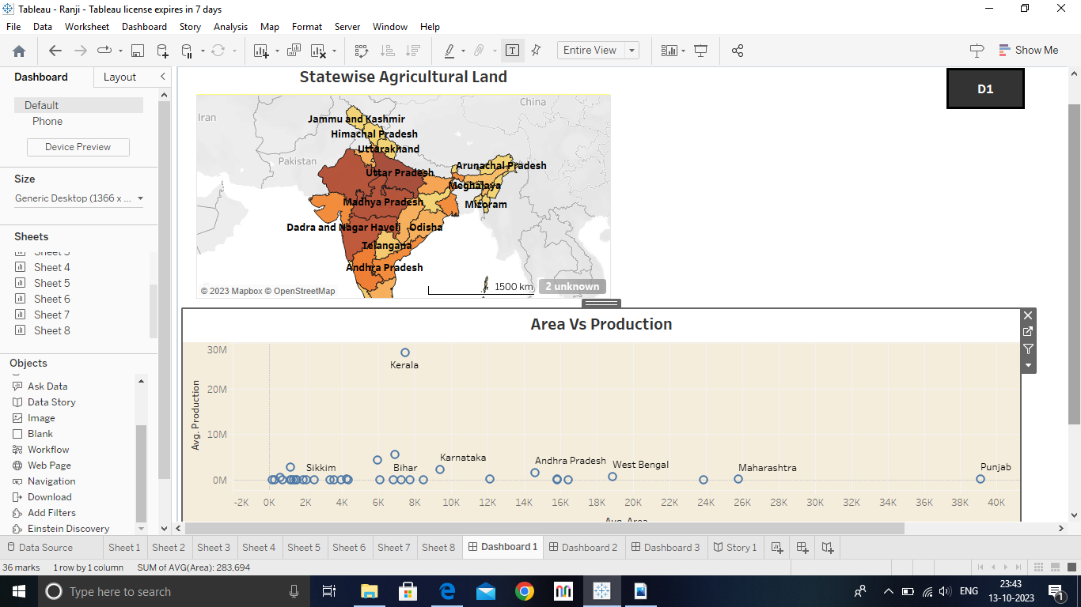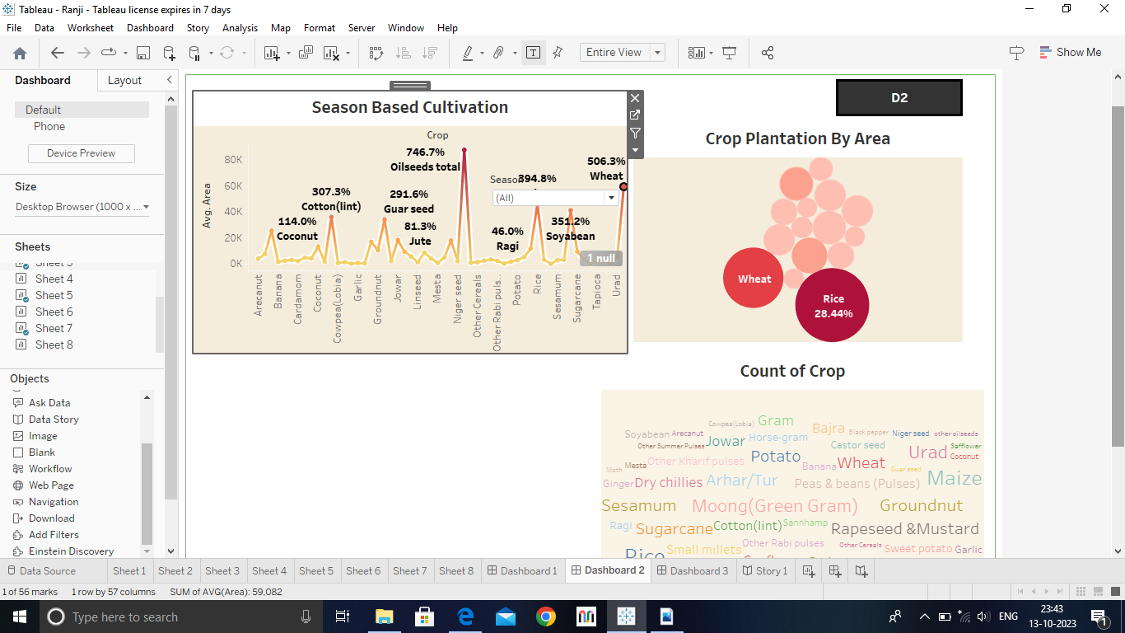

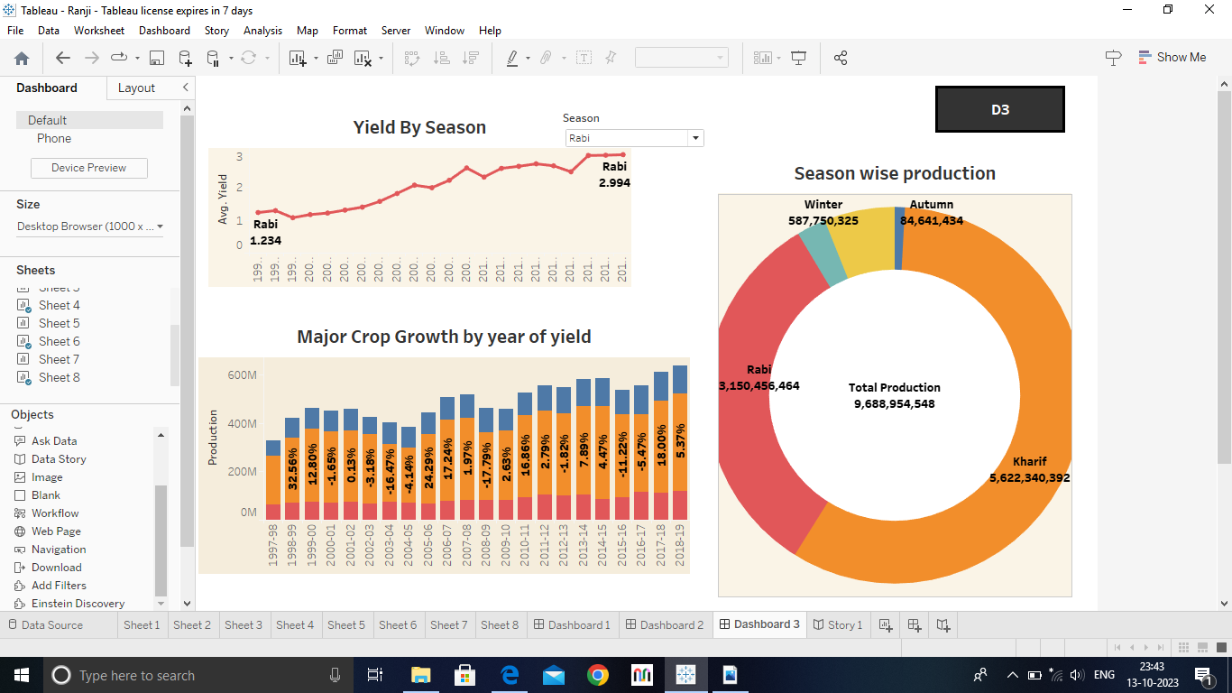

**4.Advantages and Disadvantages:**

**Advantages: Natural environment, no chemicals, eye on you, environmentally friendly, healthier and tastier.**

**Disadvantages: Expensive products, more labour, high MRP, labour charges, cross breeding problem**.

**5.Applications:**

**Simple, scalable and affordable next-generation solutions to drive agricultural innovations.**

**6.Conclusion:**

**India has achieved remarkable growth in foodgrains production in the last four decades.**

**7.Future scope:**

**Agriculture is good for the future as it is expected to use advanced technologies and innovations to produce more food with limited land and resources, increase efficiency on farms, and become more profitable, efficient, safe, and environment friendly.**